**Creating Microservices for account and loan**

In this hands on exercises, we will create two microservices for a bank. One microservice for handing accounts and one for handling loans.

Each microservice will be a specific independent Spring RESTful Webservice

maven project having it's own pom.xml. The only difference is that, instead of having both account and loan as a single application, it is split into two

different applications. These webservices will be a simple service without any backend connectivity.

Follow steps below to implement the two microservices:

**Account Microservice**

1.Create folder with employee id in D: drive

2.Create folder named 'microservices' in the new folder created in

previous step. This folder will contain all the sample projects that we will

create for learning microservices.

3.Open https://start.spring.io/ in browser

4.Enter form field values as specified below:

**5.Group:** com.cognizant

**6.Artifact:** account

7.Select the following modules

8.Developer Tools > Spring Boot DevTools

9.Web > Spring Web

10.Click generate and download the zip file

11.Extract 'account' folder from the zip and place this folder in the

'microservices' folder created earlier

12.Open command prompt in account folder and build using mvn clean

package command

13.Import this project in Eclipse and implement a controller method for

getting account details based on account number. Refer specification

14.below:

15.Method: GET

16.Endpoint: /accounts/{number}

17.Sample Response. Just a dummy response without any backend

connectivity.

{ number: "00987987973432", type: "savings", balance: 234343 }

Launch by running the application class and test the service in browser

**Loan Microservice**

Follow similar steps specified for Account Microservice and implement a

service API to get loan account details

Method: GET

Endpoint: /loans/{number}

Sample Response. Just a dummy response without any backend

connectivity.

{ number: "H00987987972342", type: "car", loan: 400000, emi: 3258, tenure:

18 }

Launching this application by having account service already running

This launch will fail with error that the bind address is already in use

The reason is that each one of the service is launched with default port

number as 8080. Account service is already using this port and it is not

available for loan service.

Include "server.port" property with value 8081 and try launching the

application

Test the service with 8081 port

Now we have two microservices running on different ports.

**NOTE:** The console window of Eclipse will have both the service console

running. To switch between different consoles use the monitor icon within the

console view.

**Ans)** Account Microservice:

Account.java:

package com.cognizant.account.model;

public class Account {

private String number;

private String type;

private double balance;

public Account(String number, String type, double balance) {

this.number = number;

this.type = type;

this.balance = balance;

}

public String getNumber() {

return number;

}

public String getType() {

return type;

}

public double getBalance() {

return balance;

}

}

AccountController.java

package com.cognizant.account.controller;

import com.cognizant.account.model.Account;

import org.springframework.web.bind.annotation.*;

@RestController

@RequestMapping("/accounts")

public class AccountController {

@GetMapping("/{number}")

public Account getAccount(@PathVariable String number) {

return new Account(number, "savings", 234343.0);

}

}

**Output:**

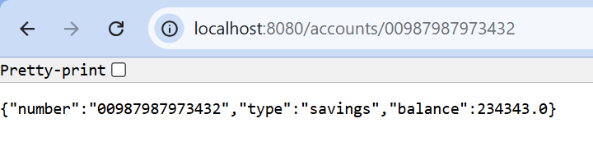

**Loan Microservice:**

**Loan.java:**

package com.cognizant.loan.model;

public class Loan {

private String number;

private String type;

private double loan;

private int emi;

private int tenure;

public Loan(String number, String type, double loan, int emi, int tenure) {

this.number = number;

this.type = type;

this.loan = loan;

this.emi = emi;

this.tenure = tenure;

}

public String getNumber() {

return number;

}

public String getType() {

return type;

}

public double getLoan() {

return loan;

}

public int getEmi() {

return emi;

}

public int getTenure() {

return tenure;

}

}

**LoanController.java:**

package com.cognizant.loan.controller;

import com.cognizant.loan.model.Loan;

import org.springframework.web.bind.annotation.*;

@RestController

@RequestMapping("/loans")

public class LoanController {

@GetMapping("/{number}")

public Loan getLoan(@PathVariable String number) {

return new Loan("H00987987972342", "car", 400000, 3258, 18);

}

}

**Output:**

